**Task 2 :Time Series Forecast**

**Given task is to perform time series forecasting for the period of may 1 , 2024 to may 7 ,2024 using the historical data of 1 april 2023 to 30 april 2024**

* **The model used here is ARIMA**
* **Starting with plotting the data for visualization and understanding**

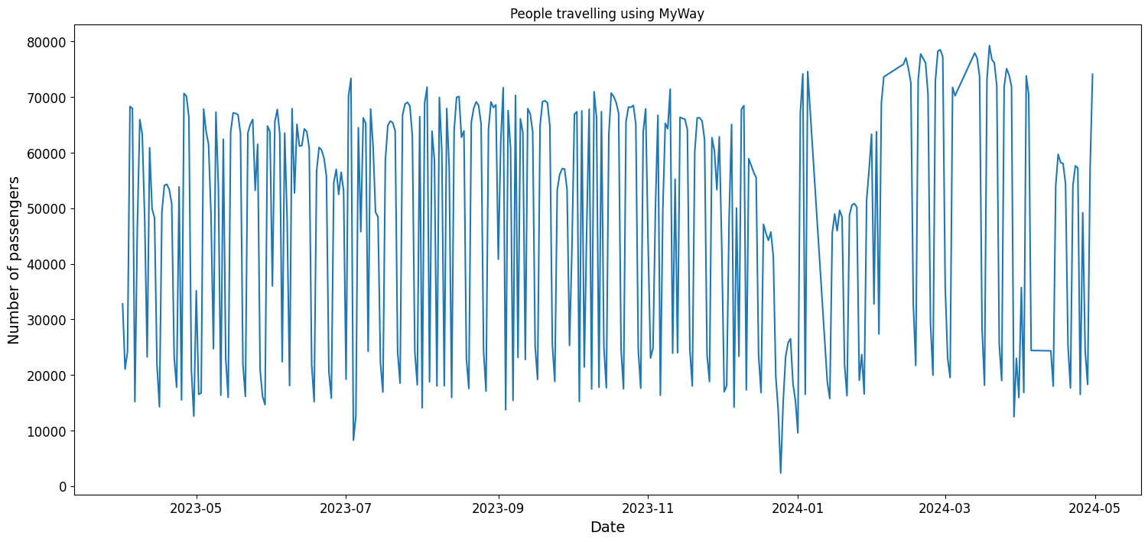

**Performing tests for stationarity**

**Results:-**

* **DF Statistic: -4.410611**
* **p-value: 0.000284**

**since p-value is less than 0.5, no need for differentiation**

**finding ACF and PACF**

* **These measures or functions help in identifying the errors upto the current lag.**
* **They prove useful for identifying ARIMA parameters**

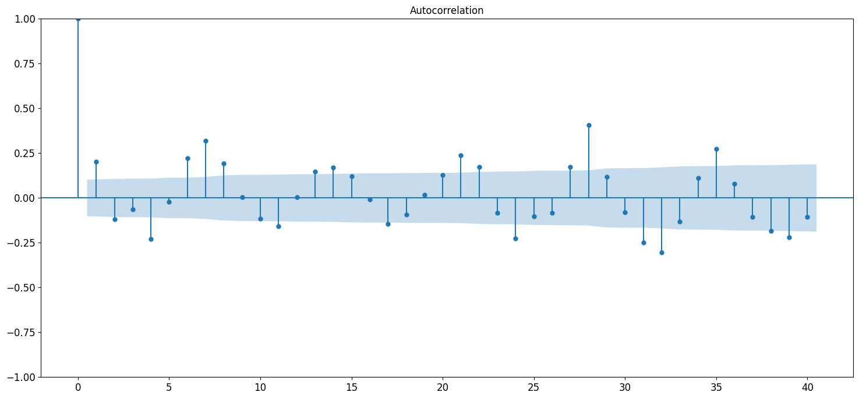

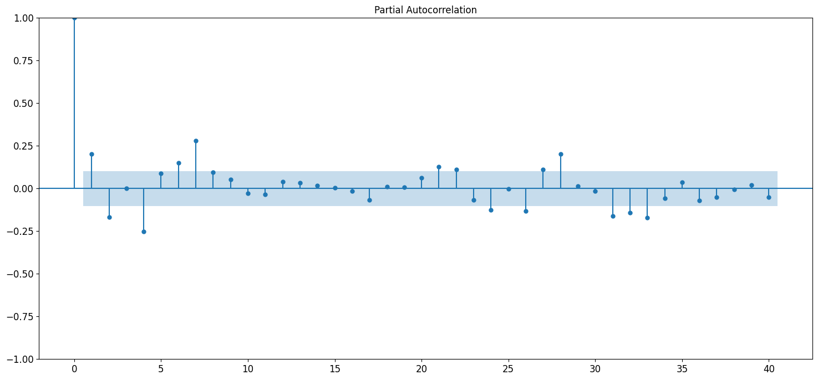

**Building the model and observing the forecasts:**

